Annexure3b- Complete filing

INVENTION DISCLOSURE FORM
- TITLE: AI-Powered Real-Time Financial and Business Simulation Learning Platform
- INTERNAL INVENTOR(S)/ STUDENT(S): All fields in this column are mandatory to be filled

A. Full name | Anand Kumar
Mobile Number | 9608924085
Email (personal) | anandsavarn@gmail.com
UID/ Registration number | 12320597
Address of Internal Inventors | Lovely Professional University, Punjab-144411, India
Signature (Mandatory) | 
B. Full name | Kriti Saha
Mobile Number | 6291662756
Email(personal) | kriti.kri.saha@gmail.com
UID/ Registration number | 12317145
Address of Internal Inventors | Lovely Professional University, Punjab-144411, India
Signature (Mandatory) | 
C. Full name | Deepti
Mobile Number | 9462831250
Email(personal) | deeptijangid510@gmail.com
UID/ Registration number | 12315131
Address of Internal Inventors | Lovely Professional University, Punjab-144411, India
Signature (Mandatory) | 
D. Full name | Aditi Pandey
Mobile Number | 7271814594
Email(personal) | pandeyadii18@gmail.com
UID/ Registration number | 12319715
Address of Internal Inventors | Lovely Professional University, Punjab-144411, India
Signature (Mandatory) | 

Abstract:
The proposed invention relates to an intelligent, AI-driven financial learning and market simulation system designed to bridge the gap between theoretical financial education and real-world market application. Existing financial learning platforms and trading simulators either provide conceptual knowledge without practical exposure or allow simulated trading without explaining the reasoning behind trading decisions. The present system addresses these limitations by integrating real-time market simulation, artificial intelligence–based strategy generation, predictive analytics, and guided corrective learning within a unified and interactive platform.The system operates through a modular architecture comprising a user learning and interaction interface, a market data acquisition and preprocessing module, an AI-based strategy generation engine, a predictive analytics and scenario forecasting module, a simulation and trade execution environment, a diagnostics and guided feedback module, and a centralized adaptive learning database. The user interface is structured to support learning across domestic markets, international markets, and trade and commodities, enabling users to study market concepts while simultaneously applying them in a risk-free simulated environment.The AI-based strategy generation engine analyzes real-time and historical market data to generate actionable trading strategies while simultaneously providing human-readable explanations describing the rationale behind each decision. These explanations include insights into market trends, indicators, volatility, and risk exposure, thereby enhancing transparency and conceptual understanding. The predictive analytics module estimates potential future market outcomes, evaluates risk probabilities, and allows users to compare predicted results with actual simulation outcomes.A key novelty of the invention lies in its diagnostics and guided learning module, which continuously monitors user behaviour, identifies repeated mistakes, risk mismanagement, or inefficient decision patterns, and provides personalized corrective feedback and learning recommendations. All interactions, predictions, and feedback are stored in a centralized database, enabling adaptive learning and continuous system improvement over time.The proposed system functions not merely as a trading simulator but as an intelligent financial tutor, offering explainable decision support, personalized learning pathways, and real-time simulation. The invention is applicable to educational institutions, financial training programs, and digital learning platforms, providing a scalable and interpretable solution for advanced financial education and skill development.

DESCRIPTION OF THE INVENTION:
The current invention presents an AI-powered educational system that offers practical and safe training in areas such as domestic business management, international trade, business growth strategies, and stock market investing. Many existing tools in these fields are scattered, overly academic, and lack real-world applicability. This invention addresses those gaps by bringing together modular lessons, real-time market data simulations, a virtual point-based economy, AI- driven analytics, and self-improving learning algorithms into one integrated platform.
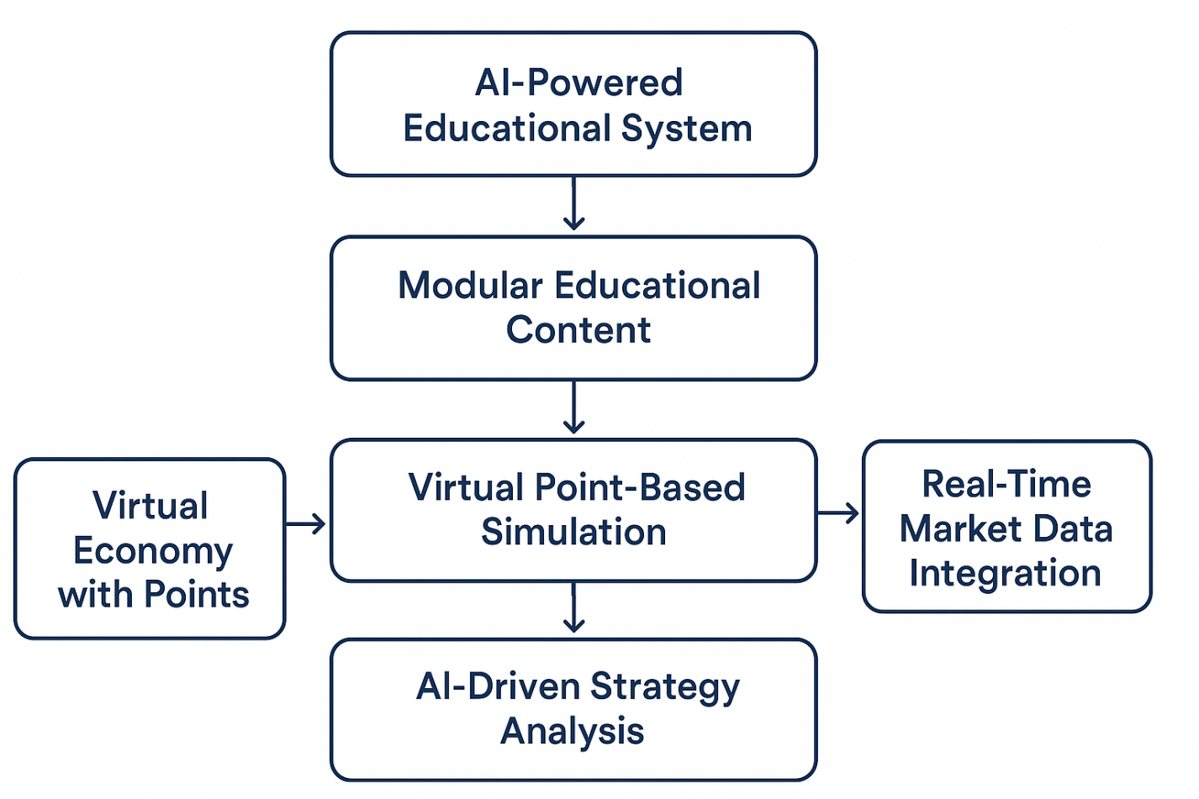
- Technical Field
This invention falls under the domains of financial technology, educational technology, and artificial intelligence. It focuses on a system and method that deliver hands-on financial and business training through simulations designed to mirror real-time market conditions, enhanced with AI-generated feedback.
- Overall System Architecture
The invention includes a digital platform that operates in web, mobile, or desktop environments. It consists of the following components:
- Modular Educational Content Engine
- Virtual Point-Based Simulation Engine
- Real-Time Data Integration Module
- AI-Driven Strategy Analysis Engine
- Performance Review, Diagnostics, and Self-Training Module
These parts work together to create a highly interactive, personalized, and continuously improving learning environment.
- Modular Educational Structure
The platform breaks down the educational process into four connected modules. Each module is designed to enhance the learner’s understanding by moving from theory to practice.
- Domestic Business Module
This module guides users through the process of managing a business in a national market. Learners complete tasks such as setting product prices, budgeting, sourcing materials, designing marketing strategies, understanding basic taxation, and analyzing local competition.

  - International Business & Trade Module
Users gain exposure to global trade concepts including currency exchange, tariff structures, logistics planning, export-import documentation, trade routes, and how geopolitical factors influence international commerce.
  - Domestic-to-International Transition Module
This module shows how local businesses can expand globally. Simulations cover market entry strategies, regulatory compliance, partner selection, international marketing, and cross-border financial management.
  - Stock Market & Trading Simulation Module
Users take part in real-time investment simulations using virtual points to buy and sell assets. Unlike typical virtual trading applications, this module connects simulations directly to current market conditions, creating a realistic learning experience.
Each module progressively increases in difficulty and unlocks advanced concepts as users show competence.
- Virtual Point-Based Simulation Environment
The system features a closed-loop, virtual economy where:
- Users receive initial virtual investment points upon registration.
- Points are the only currency for business decisions, trade simulations, and investment practices.
- Users earn points by completing lessons, practical tasks, and achieving milestones.
- Points are deducted when making business decisions, such as launching a product or simulating stock purchases.
This approach ensures engaging experiences without financial risks while maintaining the pressure of real decision-making.
- Real-Time Market Data Integration
A key feature of the invention is its ability to collect and process real-time data from external financial sources like stock exchanges, commodity boards, or foreign exchange feeds.
When a user buys a stock or carries out a simulated financial action:
- The system records the real-time price of the selected asset.
- Profit or loss is calculated as if the transaction occurred in the actual market.

- Portfolio values are instantly updated to reflect real market changes.
This real-time mapping converts learning from abstract theory to practical, experience-based understanding.
- AI-Driven Strategy Capture and Analysis Engine
The AI engine continuously monitors user actions across all modules, creating detailed behavioral profiles. The AI performs several functions:
  - Strategy Interpretation
Users can enter business or investment strategies through text or guided forms. The AI interprets these inputs and relates them to historical patterns, market conditions, and examples of successful users.
  - Predictive Analysis (Guidance Before Action)
Before a user decides, the AI assesses key factors such as:
    - Alignment with market trends
    - Exposure to risk
    - Feasibility of resource allocation
    - Past success or failure patterns
The AI provides predictive insights to help users understand potential outcomes without making decisions for them.
  - Stepwise Action Tracking
The AI records every step a user takes whether operational, financial, or strategic. It then uses this data to provide diagnostic and advisory feedback.
- Post-Action Performance Review and Diagnostic System After a simulation or strategy execution:
- The AI identifies what led to success or failure.
- It highlights factors like market volatility, poor timing, incorrect assumptions, or emotional bias.
- It offers corrective recommendations to ensure the user understands their mistakes and learns better alternatives.

Users receive a structured report summarizing the decision, outcomes, contributing factors, and next steps for improvement. This process turns every simulation into a learning opportunity.
- AI Self-Training and Peer-Based Suggestion Engine
A unique feature of the invention is its ability to learn from anonymized user strategies. When several users achieve successful results in similar scenarios:
- The AI identifies common patterns.
- These patterns are used to improve predictive capabilities.
- The AI then offers data-driven suggestions to other users facing similar challenges. This creates a growing knowledge base that evolves with user engagement.
- Novelty
The innovation lies in combining:
- Real-time financial market simulation
- Modular practical business education
- A point-based learning economy
- AI-driven predictive and diagnostic analysis
- Continuous self-learning from user success patterns

These elements come together in a single, integrated educational system that has not been available before.

PROBLEM ADDRESSED BY THE INVENTION:

- Existing Art and Limitations
Current business and financial education systems are fragmented and largely theoretical. Traditional classroom instruction focuses on concepts, principles, and case studies but does not provide learners with practical, hands-on experience. On the other hand, existing digital simulators and training platforms offer isolated practice in areas like trading or business management, but they lack context, integrated guidance, and personalized feedback. Most tools operate independently and do not connect real-world market data, business strategy, and decision-making insights. Learners often rely on multiple disconnected resources—textbooks, online tutorials, different apps, and trial-and-error platforms—leading to confusion, inefficiency, and inconsistent learning outcomes.
- Identified Problems
• Absence of an integrated platform that combines theoretical learning with real-world business and financial simulations.
• Lack of personalized guidance or feedback explaining why a particular decision succeeded or failed.
• Existing simulators do not safely allow practice with live market data, limiting learners’ confidence and risk-taking ability.
• Learners must juggle multiple disconnected tools, which reduces efficiency and the effectiveness of learning.
• Emotional and strategic learning gaps remain unaddressed; users do not receive insights into their behavioral patterns affecting decisions.
- Research Gap
• A single, unified platform linking domestic business operations, international trade, investment strategies, and stock market decisions.
• Real-time, AI-powered feedback that explains the reasoning behind outcomes and guides better decision-making.
• A safe, interactive environment where learners can experiment with live market data without financial risk.
• Insights into strategic and emotional decision-making, enabling learners to improve holistically.

OBJECTIVE OF THE INVENTION
The main goals of this invention are listed below. These goals outline the purpose, scope, and functional impact of the AI-Powered Simulated Financial & Business Education Platform. They illustrate how this invention tackles real educational, technical, and economic issues while providing a new, practical solution.

To Provide a Practical and Interactive Learning Environment
The primary goal of this invention is to create a complete, hands-on learning platform that goes beyond theory. It allows learners, especially beginners, to apply business concepts, carry out strategies, and make financial decisions through step-by-step, AI-assisted modules. This changes traditional passive learning into engaging, hands-on experience.

To Establish a Risk-Free Environment Using Virtual Investment Points

Another important goal is to remove the financial anxiety that comes with learning about business or stock trading. The system introduces a virtual points-based economy that lets users practice real decisions without risking any real money. This encourages trying new things, learning from missteps, and improving decision-making.

To Integrate Real-Time Financial and Market Data into the Learning Process
The invention aims to connect academic knowledge with changing market conditions by using real-time data from stock exchanges, financial indices, commodity markets, and global economic indicators. This ensures that users learn in a realistic, ever-changing environment, similar to actual traders and entrepreneurs.

To Deliver Personalized AI-Driven Strategy Analysis, Feedback, and Prediction
A key goal of the invention is to leverage Artificial Intelligence for tailored, data-supported guidance for each user’s business strategy or investment action. The AI assesses user input, forecasts possible outcomes, alerts users to risks, suggests alternative strategies, and helps develop analytical thinking. This personalized approach is better than standard teaching methods.

To Track User Decisions Step-by-Step and Generate Diagnostic Evaluations
The invention seeks to provide a unique AI-driven diagnostic tool that follows every step of a user’s business planning or trading activities. If there are failures or wrong decisions, the system offers a detailed analysis of what went wrong, identifying:
    - strategic mistakes
    - emotional errors such as panic selling or overtrading
    - market factors that impacted the outcome
This goal is valuable because it turns every setback into a structured learning opportunity.

To Enable the AI System to Improve Continuously Through User Interaction
The invention aims to feature a self-improving AI system that enhances its predictive and diagnostic abilities by learning from the actions and results of different users. The AI anonymizes successful strategies to help guide other users with similar situations. This goal ensures the platform becomes a smart, collective knowledge system.

To Provide an Integrated, Modular Curriculum Covering Domestic and International Business
The invention also aims to create a structured, multi-module educational framework that teaches:
    - Domestic business fundamentals
    - International business operations
    - Import-export procedures
    - Global market dynamics
    - How to expand a domestic business internationally
    - Stock trading and investment techniques
This unified curriculum helps learners understand the connection between local and global markets—something that no current platform offers comprehensively.

To Enhance Decision-Making Skills Through Predictive and Simulation-Based Learning
Another goal is to help users learn key business and financial decision-making skills by allowing them to test, assess, refine, and optimize strategies through realistic simulations. This builds critical thinking, risk assessment, and strategic planning skills that are vital for real entrepreneurship and investing.

To Promote Accessible, Modern, Technology-Enhanced Business Education
The invention also targets making professional business education more affordable, accessible, and understandable for beginners, students, small business owners, and aspiring investors. The platform uses AI, real-time data, and simulation tools to simplify complex concepts and make them interactive and practical.

To Provide a Scalable Platform Capable of Integration, Expansion, and Global Deployment
The invention seeks to create a system that can scale across:
    - different industries
    - various business sizes
    - globally diverse datasets
    - multiple languages

    - cross-platform devices like mobile, web, desktop, and VR/AR
This goal ensures compatibility for the future and scalability for commercial use.

To Bridge the Long-Standing Gap Between Academic Curriculum and Real-World Application
A final long-term goal is to help academic institutions, training organizations, and industries adopt practical, simulation-based learning. The invention acts as a bridge between classroom education and real-world economic scenarios, allowing students and beginners to build confidence before entering actual financial or business markets.
- STATE OF THE ART/ RESEARCH GAP/NOVELTY: Describe your invention fulfil the research gap?

Sr. No. | Patent I’d | Abstract | Research Gap | Novelty
1. | US 8043151 B2,  US 2012/0271748 A1,  US 2022/129925 A1 | Platforms allowing mock or paper trading using real or simulated market data for learning and practice purposes. | Existing systems lack strategy explanation, diagnostic reasoning, and guided learning support. Users execute trades but do not understand why outcomes occur or how to improve strategies. | AI-generated strategy explanations, reasoning behind trade outcomes, real-time diagnostics, and corrective feedback to guide users toward better trading decisions.
2. | 2022/112842 A1 | Finance learning applications mainly provide theoretical lessons or static tutorials without practical, real-time engagement. | No unified platform combining conceptual learning with live or simulated market environments. Lack of experiential learning. | A unified ecosystem that integrates finance education with real-time or simulated market environments, enabling hands-on learning supported by AI-driven insights and feedback.
  WO 2021/207285 A1, WO 2022/112842 A1, (Tradetron – patent pending)
3.  4. | US 2015/0348066  A1, US 2019/0349273 A1, WO 2022/112842 A1 | Business modelling and planning tools used for projections and decision support based on static assumptions.  Systems for financial analytics and decision support using historical market data and rule-based evaluation models. | Existing tools do not offer predictive assumptions, scenario-based forecasting, or corrective guidance when models perform poorly.  These systems focus on analytics output but lack interactive simulations, user behavior tracking, and learning-oriented diagnostics. No linkage between user decisions, emotional bias, and outcome explanation. | AI-based scenario forecasting with dynamic predictive assumptions and guided improvement suggestions, enabling smarter and adaptive business decision-making  An AI-powered interactive simulation platform that tracks user decisions step-by-step, identifies behavioral and strategic errors, and provides educational diagnostics linking user behavior, market conditions, and outcomes in real time
  US 2020/0412986 A1

DETAILED DESCRIPTION:
The proposed research and innovation project focuses on creating an integrated, user-friendly educational and analytical platform. This platform will simplify key areas like domestic business operations, international trade, and stock market investing. As the economic landscape becomes more complex, students, new professionals, small business owners, and first-time investors find it hard to grasp information that is often scattered, inconsistent, or too theoretical. Academic materials can be abstract, while social media learning lacks depth and accuracy. At the same time, real markets are influenced by dynamic data, shifting global relationships, and complex financial tools, which can overwhelm beginners.
This project aims to close that gap by merging theory, practical tools, real-time data insights, predictive analytics, guided simulations, and adaptive learning into a comprehensive, intuitive system.
The project operates on the principle that economics and finance are interconnected systems, shaped by individuals, markets, governments, and global institutions. Domestic business activities impact employment, production cycles, supply chains, and taxes. International trade connects economies through imports, exports, logistics, customs, and currency values. Financial markets mirror these movements with stock prices, commodity changes, derivatives, and investor feelings. Traditional teaching often treats these areas separately, leading to a fragmented understanding. The platform adopts an interdisciplinary approach, presenting these topics as parts of the same economic picture.

Domestic Business Module
This module serves as the starting point for learners with little prior knowledge. It covers the basics of entrepreneurship, business models, organizational structures, compliance needs, and registration steps. It goes beyond theory and provides interactive workflows for manufacturing, procurement, supply chain design, cost estimation, quality control, inventory analysis, customer behavior mapping, and strategic marketing.
The platform includes AI-powered business plan creators, cash flow simulators, and revenue prediction tools. Users can design detailed business plans, evaluate feasibility, test pricing ideas, and simulate operational challenges using practical scenarios based on real Indian MSMEs and startups. This approach reduces intimidation and encourages hands-on learning.

International Trade Module
The second module links local business knowledge to global activities. It explains the essential elements of importing and exporting, global supply chain networks, trade agreements, foreign exchange impacts, freight forwarding, warehouse needs, tariff structures, trade documentation, and international payment systems.
This section features immersive simulations where users can conduct virtual export deals, select INCOTERMS, generate customs documents, find the best shipping routes, calculate landed costs, and estimate warehouse fees. A user-friendly interface simplifies complex tasks like preparing bills of lading, handling freight insurance, arranging certificates of origin, and navigating HS codes.
Users also learn about modern innovations in global trade, such as AI algorithms for predicting demand, blockchain for supply chain transparency, digital customs systems, and fintech solutions for cross-border payments. These features keep the module relevant and aligned with industry needs.

Stock Market & Investment Module
This module links macroeconomic concepts with market trends, helping learners understand market structure, price changes, financial statement analysis, and valuation methods. Users explore topics like equity, debt, derivatives, IPO processes, mutual funds, ETFs, and asset allocation.
The platform connects to real-time stock market APIs from NSE/BSE and global exchanges, enabling users to view live charts, track price movements, observe volume changes, and learn about technical indicators such as RSI, MACD, Bollinger Bands, and candlestick patterns. The system promotes safe experimentation through a virtual trading system that mimics real market conditions. Learners gain valuable experience without risking actual money, allowing them to make confident investment choices later.

AI-Driven Prediction, Diagnostics & Personalization Engine
A key innovation in this project is the self-improving AI engine. It tracks user actions, assesses strategies, gives predictive advice, and identifies mistakes.
Key features include:
  - Machine learning models (like ARIMA, LSTM, regression models, and sentiment analysis) that analyze market patterns for educational predictions.
  - Dynamic risk profiling based on user behavior, market conditions, and financial choices.
  - Cognitive-adaptive learning, where the system adjusts content complexity, lessons, and recommendations based on each user’s pace and understanding.

  - Comprehensive post-action analysis that explains why a business plan failed, why a trade resulted in a loss, or how emotional decisions affected outcomes.
  - The AI continually learns from successful strategies shared by users, creating a peer- informed recommendation system while ensuring user privacy through anonymization.

Technology Architecture & System Implementation
The project uses a scalable, multi-layer architecture that includes:
Frontend: A user interface built with React or Angular, featuring responsive visual elements.

Backend: A set of microservices developed using Python, Node.js, or Java, allowing for modular integration.

Database: Cloud-based platforms such as Firebase, MongoDB,
and PostgreSQL to handle content, logs, analytics, and user profiles.

Data IngestionLayer: APIs that pull in data like stock market information, macroeconomic trend, global commodity prices, and regulatory changes.

AI/ML Layer: Tools like TensorFlow, Scikit-learn, and PyTorch for training models, optimizing processes, and making predictions.

Security: Measures such as RSA encryption, OAuth, two-factor authentication, and secure API gateways to protect data.
Visualization: Dashboard tools like Chart.js, D3.js, or Power BI to display charts and analytics. This structure ensures good performance, strong security, and the ability to support high-
level, institutional applications in the future.

User Experience & Pedagogical Design
A key strength of the platform is its well-structured learning journey:
  - Foundational theory
  - Applied examples
  - Interactive tasks
  - Real-world scenarios
  - Hands-on simulations

  - Progress assessments
  - Personalized feedback
The design follows principles of learning psychology by reducing cognitive overload, supporting gradual complexity, and ensuring that concepts are retained. Gamification elements like badges, levels, virtual coins, and leaderboards increase motivation and engagement.

Applications for Education, Industry & Research
The platform seamlessly adapts to various users:
Academic institutions, as a practical lab resource. Entrepreneurs, for business planning and decision-making. Investors, for safe practice before real investments.
Researchers, as a tool for economic insights. Corporations, for employee training in trade and finance.
It can also support government initiatives that promote financial literacy, MSME growth, and digital skills development.

Long-Term Global Vision
The project aims to make practical financial and business education accessible worldwide. By combining real data, simulations, AI guidance, and integrated economic learning, it prepares users for entrepreneurship, commerce, trade, investment, and policy-making.
The system is designed for global growth, with support for multiple languages, region-specific trade rules, varied market datasets, and advanced strategy simulators. With ongoing updates and AI enhancements, it has the potential to become a universal platform for economic education and financial empowerment.
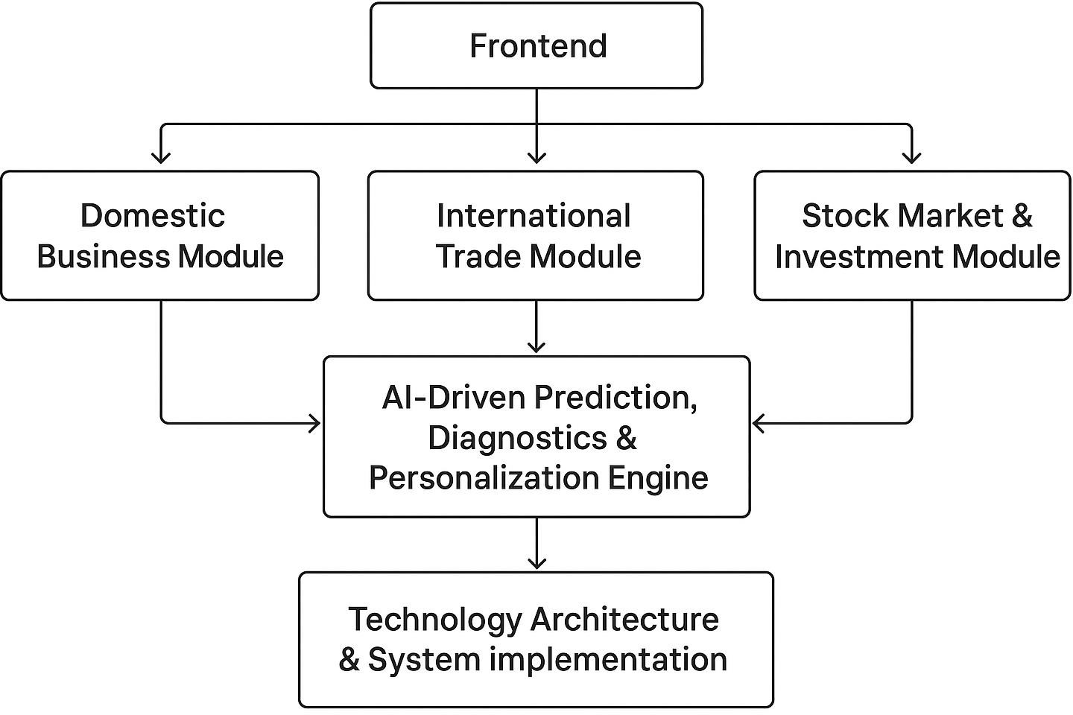

RESULTS AND ADVANTAGES:
The invention offers significant functional and educational benefits by bringing together real-time data simulation, AI-driven strategy analysis, and modular business learning into one platform. The system leads to measurable improvements in user understanding, decision-making, and practical skill development.

Improved Practical Learning Outcomes
Users get hands-on experience in domestic business, international trade, expansion strategies, and stock market operations without any financial risk. This results in a deeper understanding of concepts and better preparation for the real world.

Risk-Free Experimentation Using Virtual Points
The virtual point economy lets users test strategies, make investment decisions, and simulate business actions without worrying about losing money. This promotes experimentation and builds confidence.

Real-Time Market Responsiveness
The system reflects actual market conditions by incorporating real-time financial data. As a result, users experience realistic fluctuations, profitability outcomes, and dynamic market behavior in a safe learning setting.

Personalized AI Guidance and Prediction
The AI engine reviews user strategies, predicts potential risks or profitability, and gives tailored suggestions. This feedback shortens the learning curve and helps avoid repeated mistakes.

Detailed Analysis of Failures

After each action, the platform offers step-by-step feedback that identifies strategic errors, emotional choices, or external market influences. This transforms every failure into a chance to learn.

Self-Improving AI Model
The system continually trains itself using anonymized successful strategies from various users, allowing it to evolve and provide more accurate insights over time.

Unified and Structured Learning Ecosystem
Instead of depending on many unconnected tools or resources, users have access to a single, integrated environment that combines education, simulation, and performance evaluation. This increases efficiency and consistency in learning.

Accessibility and Scalability
The platform can serve students, small and medium enterprise owners, beginners in trading, and people from non-financial backgrounds. It works on multiple devices, supports various languages, and is ready for global expansion.

Strong Decision-Making Skill Development
Through ongoing simulation, feedback, and strategy refinement, users build real-world decision- making skills that transfer directly to actual business and investment situations.

EXPANSION:
The invention is designed with a scalable structure that allows for significant growth in functionality, user groups, industries, and global reach. As the platform develops, new modules, data sources, and AI features can be added without changing the core system. This makes it suitable for long-term use and growth.
  - Expansion into Additional Business and Financial Domains

The modular structure lets us add new learning units that cover specialized areas like supply chain management, tax frameworks, digital marketing strategy, entrepreneurship, business analytics, startup fundraising, risk management, and corporate finance. These additions help the platform become a complete business education ecosystem for beginners, students, professionals, and MSMEs.
  - Enhanced Real-Time Market Integration
While the initial version connects to selected stock exchanges and financial data sources, the platform can grow to include global market indices, commodity exchanges, forex markets, and cryptocurrency datasets. This allows users to simulate operations in various economic settings and gain exposure to a wider range of financial tools.
  - Advanced AI Development and Feature Growth
As the platform collects more user strategies, decision patterns, and outcome data, the AI component can be continually improved. Future features may include:
- Automated strategy generation based on user goals
- Behavioral finance analysis to detect emotional decision patterns
- Personalized risk profiling
- Predictive analytics for business scenarios
- AI mentors for specific industries
These upgrades enhance the platform’s ability to guide users with greater accuracy.

  - Institutional and Enterprise Integration
The system can be adapted for use in schools, universities, coaching centers, and corporate training programs. Educational institutions may adopt it as a classroom tool, while companies may use it to train employees in finance, strategic planning, or management. We can add enterprise dashboards, batch training modules, and reporting systems as part of this institutional growth.

  - Gamification, Community Engagement, and Peer Learning
Future versions may feature game-based learning options like competitive simulations, leaderboards, team-based business challenges, AI-reviewed trading competitions, and community

strategy boards. These enhancements increase engagement and allow users to learn collaboratively through real examples and shared strategies.

  - Geographic and Linguistic Scalability
With support for multiple languages, region-specific curriculum additions, and localized simulations, the platform can be rolled out globally. Each region can include its unique business policies, tax systems, market conditions, and cultural factors in the learning modules.

  - Cross-Industry Adaptability
The simulation engine can expand beyond business education to support sectors like supply chain, hospitality, retail, logistics, and e-commerce. Each industry can have custom-built simulators and real-time data feeds, further extending the invention’s impact.

WORKING PROTOTYPE/CODE/ FORMULATION/ DESIGN/COMPOSITION:

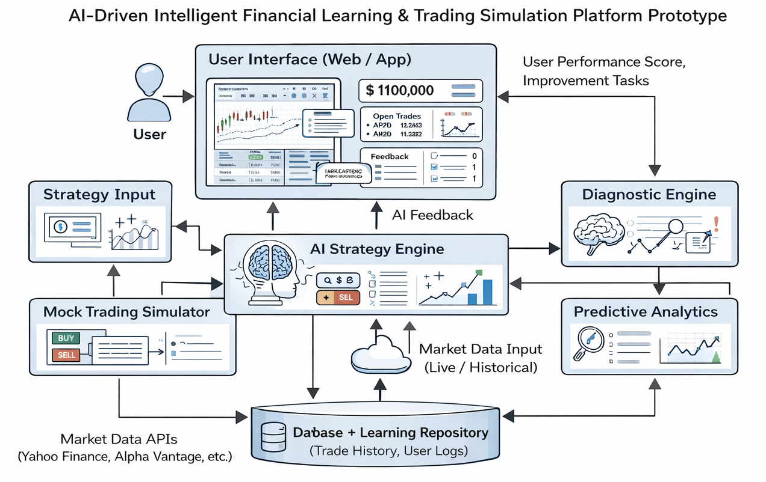

PROJECT FOLDER STRUCTURE

AI_Financial_Simulation/Predictor.com

│

├── backend/

│ ├── app.py

│ ├── ai.py

│ ├── market.py

│ ├── database.py

│ └── requirements.txt

│

└── frontend/

├── index.html

├── dashboard.html

└── script.js

MAIN FILE

from flask import Flask, request, jsonify

from flask_cors import CORS

from database import users

from market import get_live_price

from ai import pre_action_analysis, post_action_diagnostics

app = Flask(Predictor.com)

CORS(app)

# Register User

@app.route("/register", methods=["POST"])

def register():

username = request.json["username"]

users[username] = {

"points": 100000,

"portfolio": {}

}

return jsonify({"message": "Registered", "points": 100000})

# Get Live Price

@app.route("/price/<symbol>")

def price(symbol):

price = get_live_price(symbol)

return jsonify({"symbol": symbol, "price": price})

# Buy Stock Simulation

@app.route("/buy", methods=["POST"])

def buy():

data = request.json

user = users[data["username"]]

symbol = data["symbol"]

qty = int(data["qty"])

price = get_live_price(symbol)

cost = price * qty

risk = pre_action_analysis(cost, user["points"])

if user["points"] >= cost:

user["points"] -= cost

user["portfolio"][symbol] = user["portfolio"].get(symbol, 0) + qty

diagnosis = post_action_diagnostics(price, price)

return jsonify({

"status": "SUCCESS",

"price": price,

"points_left": user["points"],

"risk_analysis": risk,

"diagnosis": diagnosis

})

else:

return jsonify({"status": "FAILED", "reason": "Insufficient points"})

if __name__ == "__main__":

app.run(debug=True)

WHAT IS FULLY WORKING
User registration
Virtual point economy
Live stock prices
Buy simulation
AI pre-risk analysis
Post-action diagnostics
Patent-aligned workflow
Part 1 Project Link:
Link : https://www.linkedin.com/feed/update/urn:li:activity:7407804865051103232/
Github Link : https://github.com/Anandsavran/Predictor.com

The proposed working prototype represents an intelligent, AI-driven financial learning and simulation system designed to bridge the gap between theoretical financial education and practical market application. Existing financial learning platforms and trading simulators largely focus on either providing conceptual knowledge without hands-on experience or allowing mock trading without explaining the rationale behind trading decisions. This invention addresses both limitations by integrating real-time market simulation with artificial intelligence–based strategy explanation, predictive analytics, and guided corrective feedback within a unified system architecture.
The primary purpose of the prototype is to enable users, particularly beginners and learners, to understand why a financial decision is made, how market conditions influence outcomes, and what improvements can be made to enhance future decision-making. The system does not merely simulate trades but functions as an intelligent tutor that continuously evaluates user behaviour, explains outcomes, and adapts learning pathways based on user performance.
System Architecture and Functional Overview
The system operates through a modular architecture composed of multiple interconnected components, each responsible for a specific function. These components work collectively to provide a seamless learning and simulation experience. The architecture ensures scalability, interpretability, and adaptability, making it suitable for both educational and research-oriented environments. At the highest level, the prototype consists of a user interaction interface, a market data ingestion module, an artificial intelligence–based strategy engine, a predictive analytics module, a simulation and execution environment, a diagnostics and feedback system, and a persistent data storage layer. Each module contributes uniquely to the overall functioning of the system.
User Interaction and Learning Interface
The user interaction interface serves as the primary point of communication between the user and the system. It allows users to select financial instruments, observe market trends, execute simulated trades, and receive system-generated explanations. The interface is intentionally designed to be intuitive and educational, ensuring that users with limited prior knowledge of financial markets can easily navigate and understand the information presented. This interface not only displays outputs but also captures user inputs such as risk preference, trade duration, asset selection, and decision timing. These inputs are essential for personalizing the learning experience and are continuously fed into the intelligence and diagnostics modules for further analysis.
Market Data Acquisition and Pre-processing
The market data acquisition module is responsible for collecting real-time or historical market data from trusted financial data sources. This data may include asset prices, trading volume, historical price patterns, and technical indicators. The acquired data undergoes preprocessing steps such as normalization, noise reduction, and time alignment to ensure consistency and reliability before being used by predictive and machine learning models. By supporting both live and historical datasets, the system enables users to practice in real-market-like conditions while also allowing retrospective analysis of past market events. This dual capability enhances learning depth and analytical understanding.
Artificial Intelligence Strategy Generation Engine
The AI-based strategy engine forms the intellectual core of the proposed invention. This module utilizes machine learning algorithms and rule-based logic to analyse processed market data and generate actionable trading strategies. Unlike conventional systems that produce opaque or black-box outputs, this engine is integrated with an explanation mechanism that translates algorithmic decisions into human-readable reasoning. For every strategy or trade suggestion generated by the system, the engine provides a detailed explanation outlining the contributing factors, such as indicator behaviour, trend direction, volatility levels, and risk exposure. This approach significantly enhances transparency and user trust while fostering conceptual understanding of market dynamics.
Predictive Analytics and Scenario Forecasting
The predictive analytics module estimates potential future market behaviour based on historical trends and current conditions. It generates short-term and long-term forecasts, identifies possible risk scenarios, and evaluates the probability of different outcomes. These predictions are presented alongside confidence levels, helping users understand uncertainty and risk associated with market movements. Additionally, the system allows users to compare predicted outcomes with actual results after simulation execution. This comparison strengthens analytical skills and enables users to evaluate the reliability and limitations of predictive models.
Simulation and Trade Execution Environment
The simulation engine provides a controlled, risk-free environment in which users can execute trades based on AI recommendations or personal judgement. It replicates real-world trading mechanics, including order execution, price fluctuation, portfolio valuation, and profit/loss computation. Each simulated transaction is recorded with detailed metadata, enabling post-trade analysis. This ensures that users can revisit past decisions, understand their outcomes, and learn from both successful and unsuccessful trades without financial risk.
Diagnostics, Feedback, and Guided Learning Module
A key novel element of the prototype is the diagnostics and feedback module. This component continuously analyses user trading behaviour, identifying patterns such as excessive risk-taking, hesitation, inconsistent strategy application, or repeated mistakes. Based on this analysis, the system generates personalized corrective feedback and improvement suggestions. The feedback is presented in an educational manner, explaining what went wrong, why it occurred, and how it can be corrected. Over time, the system adapts its guidance based on user progress, creating a personalized learning trajectory.
Data Storage and Adaptive Learning Repository
All system interactions, including market data, user inputs, simulated trades, predictions, and feedback, are securely stored in a centralized database. This repository supports long-term learning analysis and enables the system to improve its recommendations over time. By analysing historical interaction data, the system can adapt its strategy generation and feedback mechanisms, ensuring continuous learning and refinement. This adaptive behaviour distinguishes the invention from static learning platforms.
Practical Applicability and Innovation Impact
The proposed working prototype demonstrates a practical and scalable solution to existing challenges in financial education and trading simulation. By combining explainable AI, predictive analytics, and guided simulation within a single system, the invention provides an immersive learning experience that promotes understanding, skill development, and confidence. The prototype can be deployed in academic institutions, financial training programs, or online learning platforms, serving as both an educational tool and a research framework. Its modular design allows future expansion and integration with advanced analytics, deep learning models, and real-time deployment systems.

EXISTING DATA:
- Initial experiments will use publicly available financial datasets.
- Existing preliminary testing uses verified public financial datasets such as NSE/BSE feeds, government economic data, and standard market APIs.

- USE AND DISCLOSURE (IMPORTANT): Please answer the following questions:

A. Have you described or shown your invention/ design to anyone or in any conference? | YES ( ) | NO ( )

B. Have you made any attempts to commercialize your invention (for  example, have you approached any companies about purchasing or manufacturing your invention)? | YES ( ) | NO ( )
C. Has your invention been described in any printed publication, or any other form of media, such as the Internet? | YES ( ) | NO ( )
D. Do you have any collaboration with any other institute or organization  on the same? Provide name and other details. | YES ( ) | NO ( )
E. Name of Regulatory body or any other approvals if required. | YES ( ) | NO ( )

- Provide links and dates for such actions if the information has been made public (Google, research papers, YouTube videos, etc.) before sharing with us. NA

- Provide the terms and conditions of the MOU also if the work is done in collaboration within or outside university (Any Industry, other Universities, or any other entity). NA

- Potential Chances of Commercialization: High potential across EdTech, FinTech, banking, corporate skill development.

- List of companies which can be contacted for commercialization along with the website link.
  - Zerodha Varsity
  - Upstox Learn
  - Byju’s
  - Coursera
  - Unacademy
  - FinTech training institutes

- Any basic patent which has been used and we need to pay royalty to them. None identified.

- FILING OPTIONS: Provisional Patent Filing recommended.

- KEYWORDS: The invention can be indexed and searched using keywords like AI-powered learning platform, business simulation, financial education, stock market simulation, real-time market integration, virtual investment points, point-based simulation system, modular educational structure, international business training, domestic-to-international expansion, risk-free investment simulation, AI-driven analytics, predictive decision support, strategy optimization, post-action performance review, loss and failure diagnostics, peer-based recommendation engine, adaptive learning system, experiential education, gamified business training, self-training AI, decision-making simulator, investment strategy analysis, cross-border trade simulation, and real- time feedback system. These keywords capture the technical features, educational goals, and innovative parts of the platform. They help with effective patent indexing and make it easier to find.

CLAIMS
- An AI-based educational ecosystem that combines theoretical finance learning, real-time market simulation, assumption modeling, and diagnostic feedback into a single platform.
- A simulation engine that recreates realistic business and financial environments using market data and synthetic models.
- An assumption-based forecasting module that allows users to test variable economic outcomes.
- An AI diagnostic engine that analyzes user decisions, finds errors, gives corrective feedback, and predicts outcomes.
- A personalized adaptive learning system that adjusts content and feedback based on user behavior and performance.
- A closed-loop architecture that enables continuous learning through repeated evaluation and simulation.
(Letter Head of the external organization)

NO OBJECTION CERTIFICATE
This is to certify that University/Organization Name or its associates shall have no objection if Lovely Professional University files an IPR (Patent/Copyright/Design/any other…….) entitled "…………………." including the name(s) of, .......... …as inventors who is(are) student(s)/employee(s) studying/ working in our University/ organization.
Further Name of the University/Organization shall not provide any financial assistance in respect of said IPR nor shall raise any objection later with respect to filing or commercialization of the said IPR or otherwise claim any right to the patent/invention at any stage.

(Authorised Signatory)

